

Republic of the Philippines
SULTAN KUDARAT STATE UNIVERSITY
Isulan campus, Isulan Sulatn Kudarat
2nd Semester S.Y. 2024-2025

CC113 COMPUTER PROGRAMMING 2
MIDTERM EXAMINATION
March 19-21, 2025

Name: ____________________________________________Course & Year:______________Score:________

General Instructions:
1. Read each question carefully.
2. Write your answer in the space provided before the number.
3. STRICTLY NO ERASURES. Erasures will be considered incorrect.
4. Choose the best option.

Testy I. MULTIPLE CHOICE.
___1. What is the purpose of the if statement in C++?
A) To repeat a block of code multiple times B) To control the flow of the program based on a condition
C) To define a function D) To declare a variable
___2. What is the correct syntax for an if statement in C++?
A) if condition { // code } B) if (condition) { // code }
C) if {condition} // code D) if [condition] { // code }
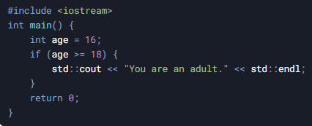
___3. In the following code, what will be the output if the value of age is 16?
A) "You are an adult."
B) "You are not an adult."
C) No output
D) Compilation error
___4. What is the purpose of nested if statements in C++?
A) To repeat a block of code multiple times B) To test multiple conditions and execute different blocks of code
C) To define multiple functions D) To declare multiple variables
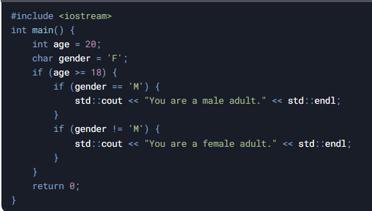
___5. In the following code, what will be the output if the value of age is 20 and gender is 'F'?

A) "You are a male adult."
B) "You are a female adult."
C) No output
D) Compilation error
___6. What is the primary purpose of the if...else statement in C++?
A) To repeat a block of code multiple times B) To execute different code blocks based on a condition
C) To define a function D) To declare a variable
___7. What is the correct syntax for an if...else statement in C++?
A) if (condition) { // code } else { // code } B) if condition { // code } else { // code }
C) if {condition} // code else { // code } D) if [condition] { // code } else { // code }
___8. What is the purpose of the else if clause in an if...else statement?
A) To repeat a block of code B) To test additional conditions after the initial if condition
C) To define a new function D) To declare a new variable
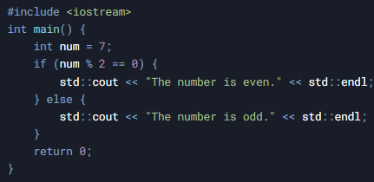
___9. In the following code, what will be the output if the value of num is 7?
A) "The number is even."
B) "The number is odd."
C) No output
D) Compilation error

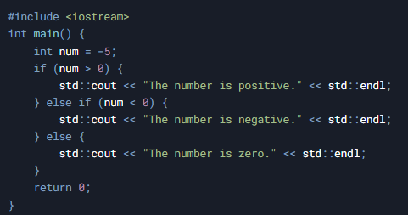
___10. In the following code, what will be the output if the value of num is -5?
A) "The number is positive."
B) "The number is negative."
C) "The number is zero."
D) No output
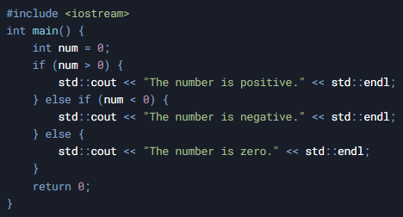
___11. What will be the output of the following code if the value of num is 0?
A) "The number is positive."
B) "The number is negative."
C) "The number is zero."
D) No output

___12. What is the purpose of nesting if...else statements?
A) To repeat a block of code multiple times B) To test multiple conditions and execute different code blocks
C) To define multiple functions D) To declare multiple variables
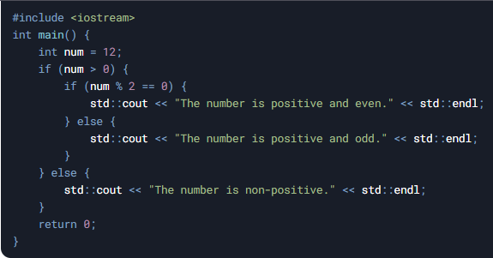
___13. In the following code, what will be the output if the value of num is 12?
- "The number is positive and even."
- "The number is positive and odd."
- "The number is non-positive."
- No output

___14. Which of the following is true about the else block in an if...else statement?
A) It is executed when the if condition is true.
B) It is executed when the if condition is false.
C) It is optional and can be omitted.
D) It is used to define a new condition.
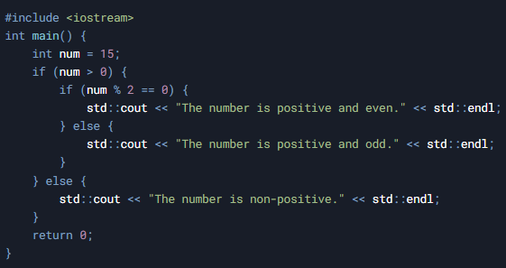
___15. What will be the output of the following code if the value of num is 15?
A) "The number is positive and even."
B) "The number is positive and odd."
C) "The number is non-positive."
D) No output

___16. What is the primary purpose of the if...else if...else statement in C++?
A) To repeat a block of code multiple times
B) To test multiple conditions and execute different code blocks based on those conditions
C) To define a function
D) To declare a variable
___17. What is the correct syntax for an if...else if...else statement in C++?
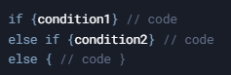
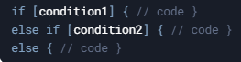
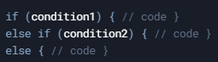
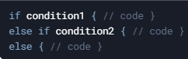

C)

D)

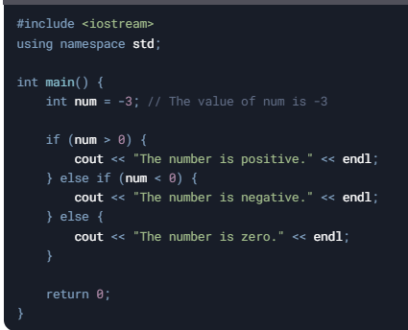
___18. In the following code, what will be the output if the value of num is -3?
A) "The number is positive."
B) "The number is negative."
C) "The number is zero."
D) No output

___19. What happens if none of the conditions in an if...else if...else statement are true?
A) The program will terminate. B) The code block in the else clause will be executed.
C) The program will throw an error. D) The program will skip the entire if...else if...else block.
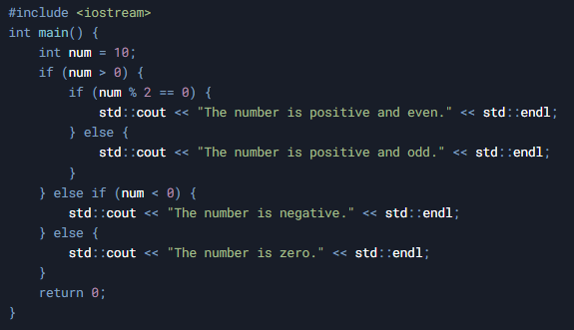
20. In the following code, what will be the output if the value of num is 10?
A) "The number is positive and even."
B) "The number is positive and odd."
C) "The number is negative."
D) "The number is zero."

___21. What is a nested decision in C++?
A) A decision structure that uses only switch statements.
B) A decision structure where one or more if...else statements are placed inside another if or else block.
C) A decision structure that only uses logical operators like && and ||.
D) A decision structure that avoids using conditions.

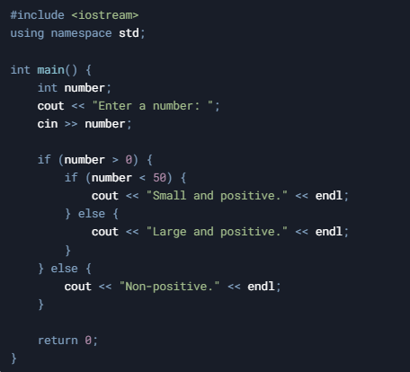
___22. What is the output of the following code if the input is 25?

A) Small and positive.
B) Large and positive.
C) Non-positive.
D) No output.

___23. Which of the following is a disadvantage of using deeply nested if...else statements?
A) They make the code more readable.
B) They simplify the logic of the program.
C) They can make the code harder to maintain and debug.
D) They reduce the number of conditions to evaluate.

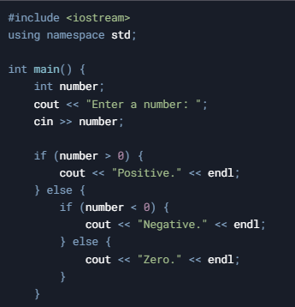
___24. What will be the output of the following code if the input is -10?
A) Positive.
B) Negative.
C) Zero.
D) No output.

___25. Which of the following is a good practice when using nested decisions?
A) Use as many levels of nesting as possible.
B) Avoid using comments to keep the code concise.
C) Refactor deeply nested code into functions or use logical operators.
D) Always use switch statements instead of if...else.

___26. What is the purpose of a while loop in C++?
A) To execute a block of code a fixed number of times.
B) To execute a block of code as long as a specified condition is true.
C) To execute a block of code only once.
D) To execute a block of code based on user input without any condition.

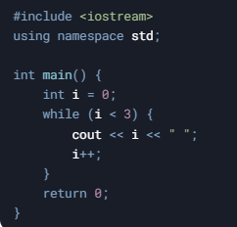
___27. What will be the output of the following code?
A) 0 1 2
B) 1 2 3
C) 0 1 2 3
D) Infinite loop

___28. What happens if the condition in a while loop is false initially?
A) The loop executes once. B) The loop executes indefinitely.
C) The loop is skipped entirely. D) The program crashes.

___29. Which of the following is a common use case for a while loop?
A) Executing a block of code a fixed number of times. B) Reading input until a valid value is entered.
C) Defining a function. D) Declaring variables.

___30. What is the key difference between a while loop and a do-while loop?
A) A while loop always executes at least once, while a do-while loop may not.
B) A do-while loop always executes at least once, while a while loop may not.
C) A while loop cannot use conditions, but a do-while loop can.
D) A do-while loop is faster than a while loop.

___31. What is the key difference between a while loop and a do-while loop?
A) A while loop always executes at least once, while a do-while loop may not.
B) A do-while loop always executes at least once, while a while loop may not.
C) A while loop cannot use conditions, but a do-while loop can.
D) A do-while loop is faster than a while loop.

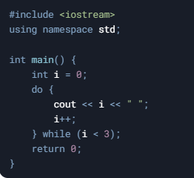
___32. What will be the output of the following code?
A) 0 1 2
B) 1 2 3
C) 0 1 2 3
D) Infinite loop

___33. What happens if the condition in a do-while loop is false initially?
A) The loop executes once. B) The loop executes indefinitely.
C) The loop is skipped entirely. D) The program crashes.

___44. Which of the following is a common use case for a do-while loop?
A) Executing a block of code a fixed number of times. B) Reading input until a valid value is entered.
C) Defining a function. D) Declaring variables.

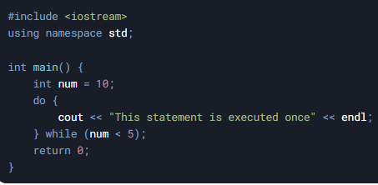
35. What is the output of the following code if the input is 10?
A) No output.
B) "This statement is executed once" (printed once).
C) "This statement is executed once" (printed infinitely).
D) Compilation error.

___36. In a do-while loop, when is the condition evaluated?
A) Before the loop body is executed. B) After the loop body is executed.
C) During the loop body execution. D) Only once at the start of the program.

___37. What is the minimum number of times a do-while loop will execute its body?
A) 0 B) 1 C) 2 D) Depends on the condition.

___38. Which of the following is true about the do-while loop?
A) It is an entry-controlled loop. B) It is an exit-controlled loop.
C) It does not require a condition. D) It cannot be nested inside another loop.

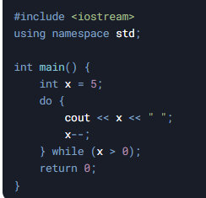
___39.What will be the output of the following code?
A) 5 4 3 2 1
B) 5 4 3 2 1 0
C) 4 3 2 1
D) Infinite loop

___40: Which of the following is a disadvantage of using a do-while loop?
A) It cannot handle conditions. B) It always executes at least once, even if the condition is false.
C) It is slower than a while loop. D) It cannot be used for input validation.

___41: What are the three essential components of a for loop in C++?
A) Initialization, condition, and loop body. B) Initialization, condition, and increment/decrement.
C) Condition, loop body, and break statement. D) Initialization, loop body, and return statement.

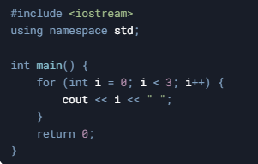
___42. What will be the output of the following code?
A) 0 1 2
B) 1 2 3
C) 0 1 2 3
D) Infinite loop

___43. What happens if the condition in a for loop is false initially?
A) The loop executes once. B) The loop executes indefinitely.
C) The loop is skipped entirely. D) The program crashes.

___44. Which of the following is a common use case for a for loop?
A) Reading input until a valid value is entered. B) Iterating over a fixed range of values.
C) Executing a block of code at least once. D) Handling user input validation.

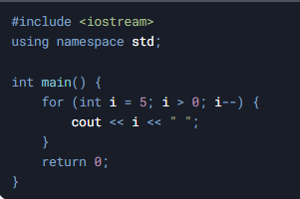
___45. What is the output of the following code?
A) 5 4 3 2 1
B) 5 4 3 2 1 0
C) 4 3 2 1
D) Infinite loop

___46. In a for loop, when is the increment/decrement step executed?
A) Before the loop body is executed. B) After the loop body is executed.
C) Before the condition is checked. D) Only once at the start of the program.

___47. Which of the following is true about the for loop?
A) It is an exit-controlled loop. B) It always executes at least once.
C) It is ideal for iterating over a known range of values. D) It cannot be nested inside another loop.

___48. What is a nested loop in C++?
A) A loop that contains another loop inside its body. B) A loop that runs indefinitely.
C) A loop that can only be used with arrays. D) A loop that executes only once.

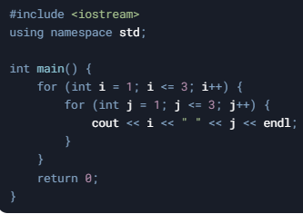
___49. What will be the output of the following code?
A) 1 1, 1 2, 1 3, 2 1, 2 2, 2 3, 3 1, 3 2, 3 3
B) 1 1, 2 2, 3 3
C) 1 2 3, 1 2 3, 1 2 3
D) Infinite loop

___50. Which of the following is a common use case for nested loops?
A) Reading a single input value. B) Printing patterns or working with multidimensional arrays.
C) Executing a block of code only once. D) Declaring variables.

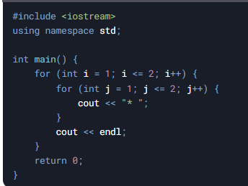
___51. What is the output of the following code?
A) *
B) * *
C) * ***
D) * * * ***

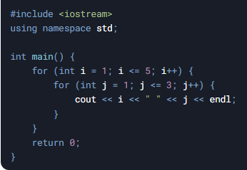
___52. How many times will the inner loop execute in the following code?

A) 5
B) 3
C) 15
D) 8

___53. What is the role of the outer loop in nested loops?
A) It controls the execution of the inner loop. B) It executes only after the inner loop completes.
C) It is optional in nested loops. D) It cannot contain another loop.

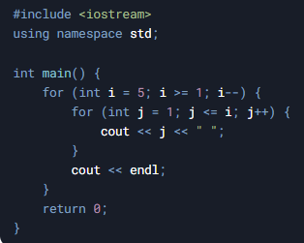
___54. What will be the output of the following code?

A) 1 2 3 4 5 B) 5 4 3 2 1 C) 1 2 3 4 5 D) Infinite loop
1 2 3 4 4 3 2 1 2 3 4 5
1 2 3 3 2 1 3 4 5
1 2 2 1 4 5
1 1 5

___55. Which of the following is true about nested loops?
A) The inner loop must always run fewer times than the outer loop.
B) The inner loop is executed completely for each iteration of the outer loop.
C) Nested loops cannot be used with while or do-while loops.
D) Nested loops are only used for mathematical calculations.

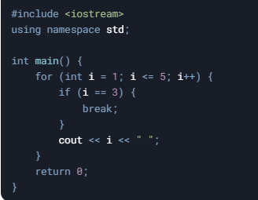
___56. What will be the output of the following code?
A) 1 2 3
B) 1 2
C) 1 2 3 4 5
D) 3

___57. In which of the following scenarios is the break statement most useful?
A) When you want to skip the current iteration of a loop.
B) When you want to terminate a loop based on a specific condition.
C) When you want to execute a loop indefinitely.
D) When you want to declare a variable inside a loop.

___58. What will happen if the break statement is used outside of a loop or switch statement in C++?A) The program will compile and run without errors.
B) The program will compile but produce a runtime error.
C) The program will not compile and produce a syntax error.
D) The program will execute the break statement as if it were inside a loop.

___59. How does the break statement behave in nested loops?
A) It terminates all nested loops simultaneously.
B) It only terminates the innermost loop in which it is placed.
C) It skips the current iteration of all nested loops.
D) It cannot be used in nested loops.

___60. How can the break statement improve the efficiency of a program?
A) By allowing the program to skip unnecessary iterations after a condition is met.
B) By increasing the number of iterations in a loop.
C) By making the program execute indefinitely.
D) By reducing the number of variables used in the program.

Prepared by:

ELBREN O. ANTONIO, DIT
Professor

Reviewed by:

CERILO B. RUBIN, JR., MIT
Program Chairperson, BSIT

Approved By:

ELBREN O. ANTONIO, DIT
Dean, College of Computer Studies

